31st March 2021

Greetings all

It’s Easter
This is the 9th week of the term and it is only four days long. Next Tuesday is also part of Easter holidays so next week will also be a short one for schools. It is easy to forget about the significance of this time of year for a Christian.
The symbolism of Easter can be confusing: it’s not all about rabbits and eggs. The hot cross buns indicate the cross that Jesus died on that we recognise on Good Friday. The rabbits and eggs symbolise his resurrection (celebrated on Easter sunday) and the new life we can have in Jesus if we accept him as our Lord. God signposted Jesus’ death and its significance, in prophecy in the bible, hundreds of years before his birth. One of my favourites is Isaiah 53 v4-7:
Surely he took up our pain
and bore our suffering,
yet we considered him punished by God,
stricken by him, and afflicted.
⁵ But he was pierced for our transgressions,
he was crushed for our iniquities;
the punishment that brought us peace was on him,
and by his wounds we are healed.
⁶ We all, like sheep, have gone astray,
each of us has turned to our own way;
and the Lord has laid on him
the iniquity of us all.
⁷ He was oppressed and afflicted,
yet he did not open his mouth;
he was led like a lamb to the slaughter,
and as a sheep before its shearers is silent,
so he did not open his mouth.
It’s comforting to know we can turn to Jesus to have our sins forgiven. God loves us all and that is why he sent Jesus to die for us so that we can be adopted into his family.
Have a wonderful Easter and a relaxing holiday.
Many blessings, Peter Ferrar

Parent teacher interviews
These will be running on Tuesday and Wednesday of Week 2 (11-12th May) and I will advise you in Week 1 of the process for booking to have a talk with your child’s teacher. They will be ten minutes in duration. Please prioritise these dates.

Students of the week:
Room 3 student of the week:
Well done!

Central Otago Primary School Athletics:

Congratulations to our COPSA competitors in athletics held on Monday in Alexandra, Monty and Cloe. Cloe did really well placing 2nd in Central Otago Primary School athletics for shot put. She threw a massive 7.65m! Congrats to both Chloe and Monty for representing our school.

Snapshots from school this week:

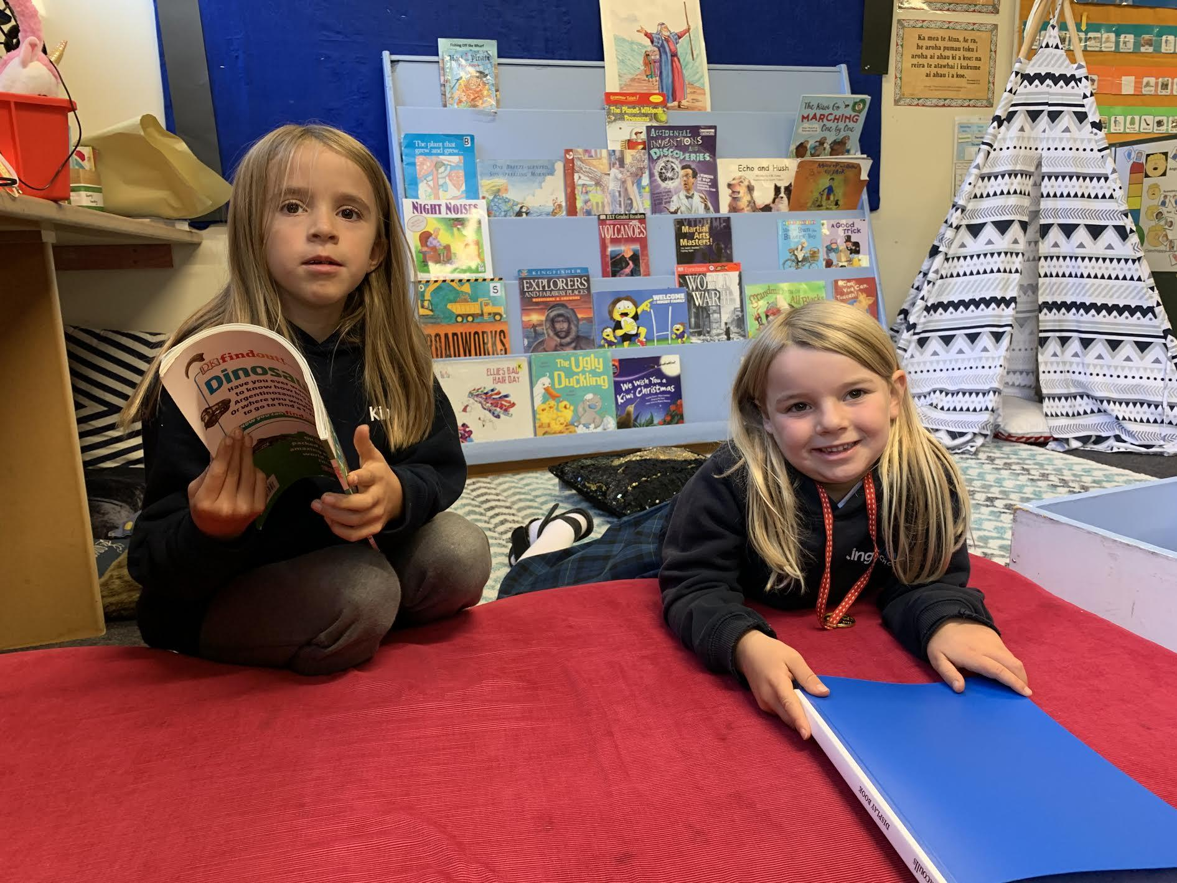 | 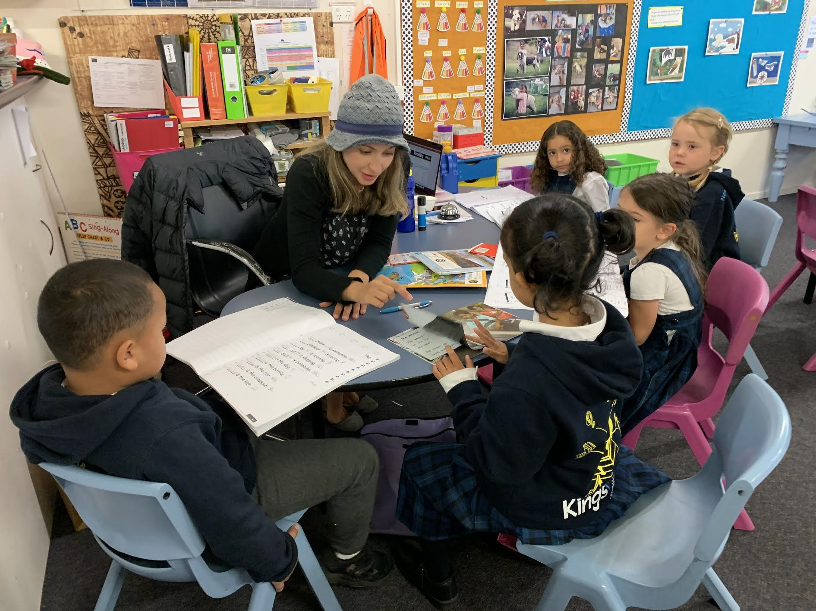
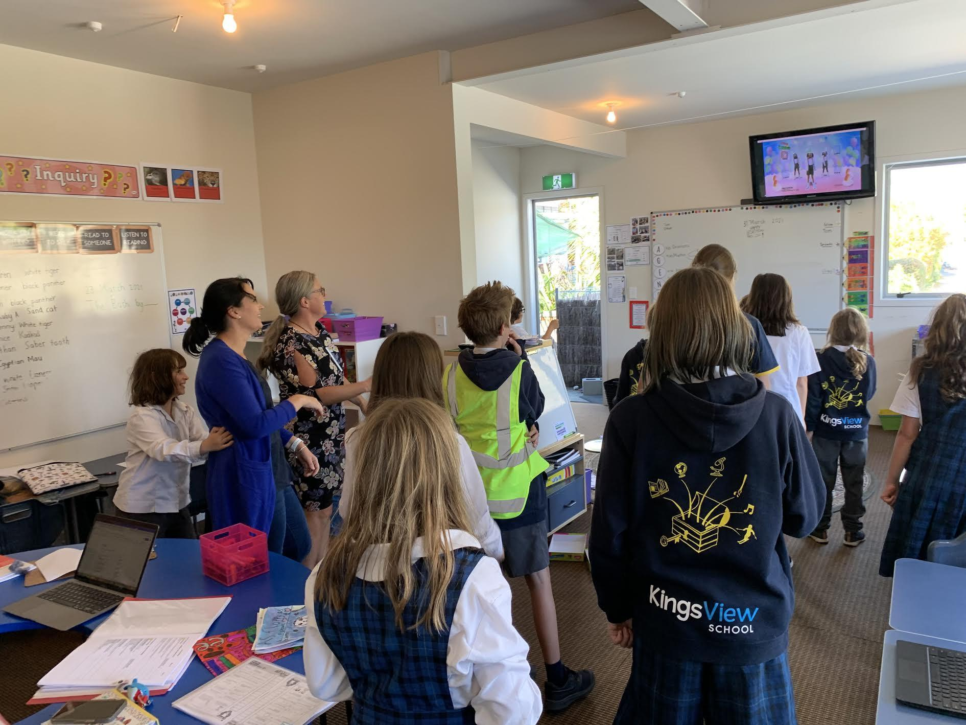  Chloe in action at COPSA | 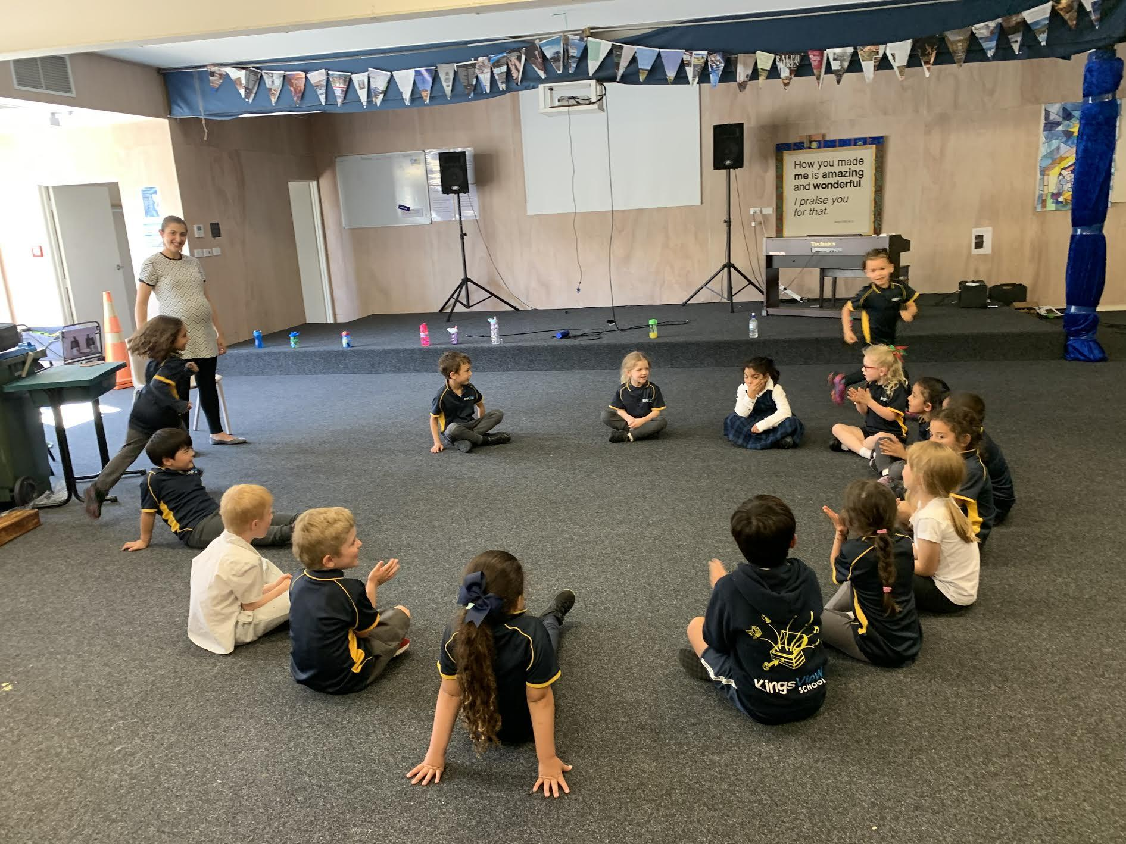
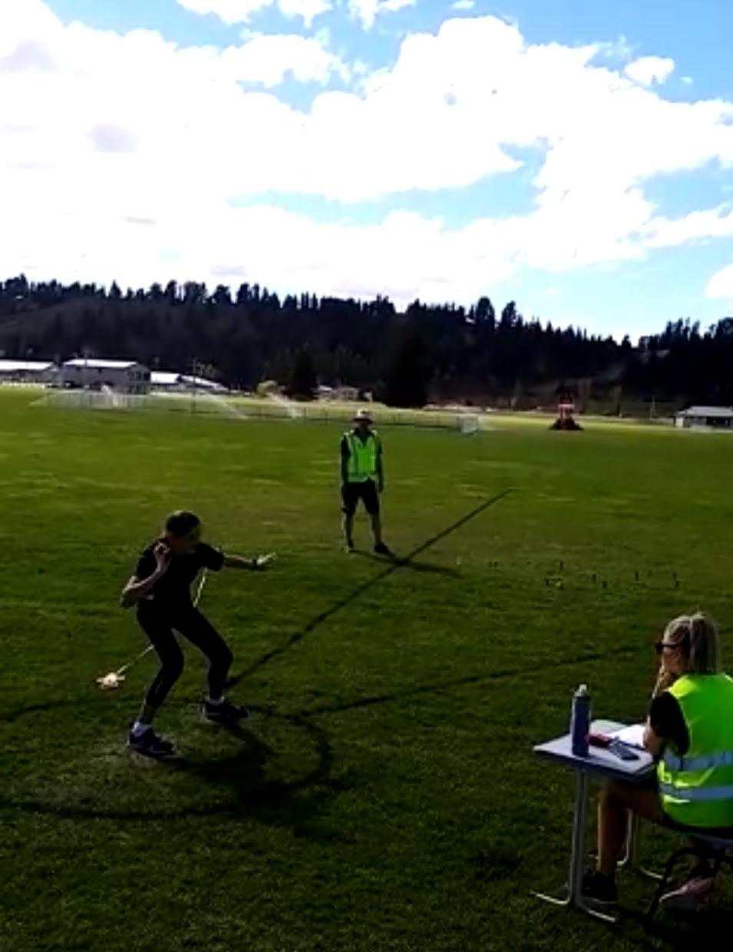 | 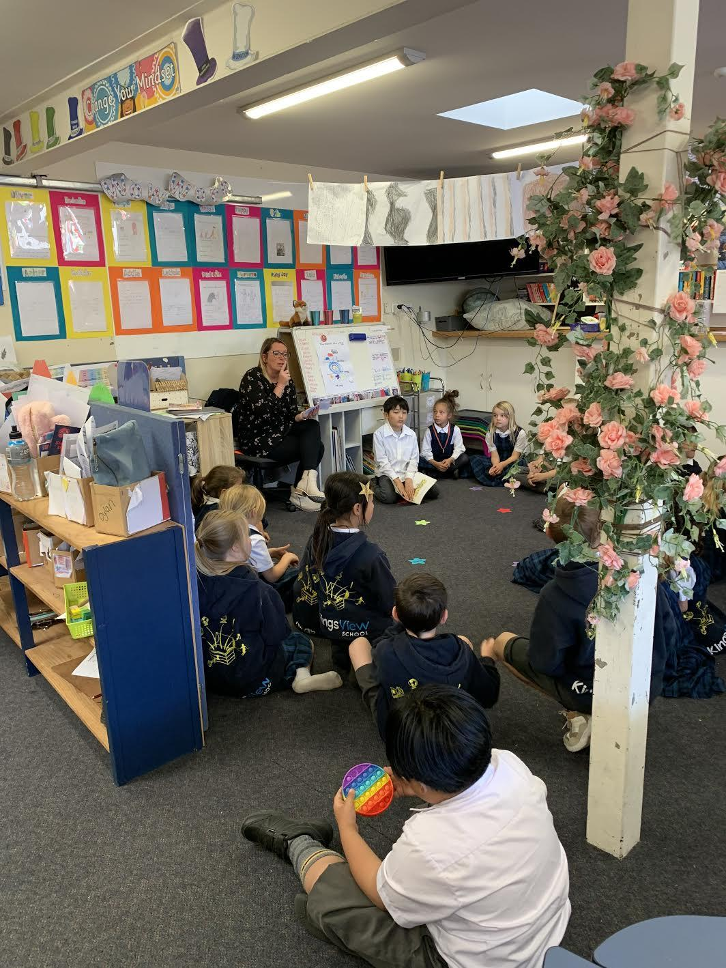
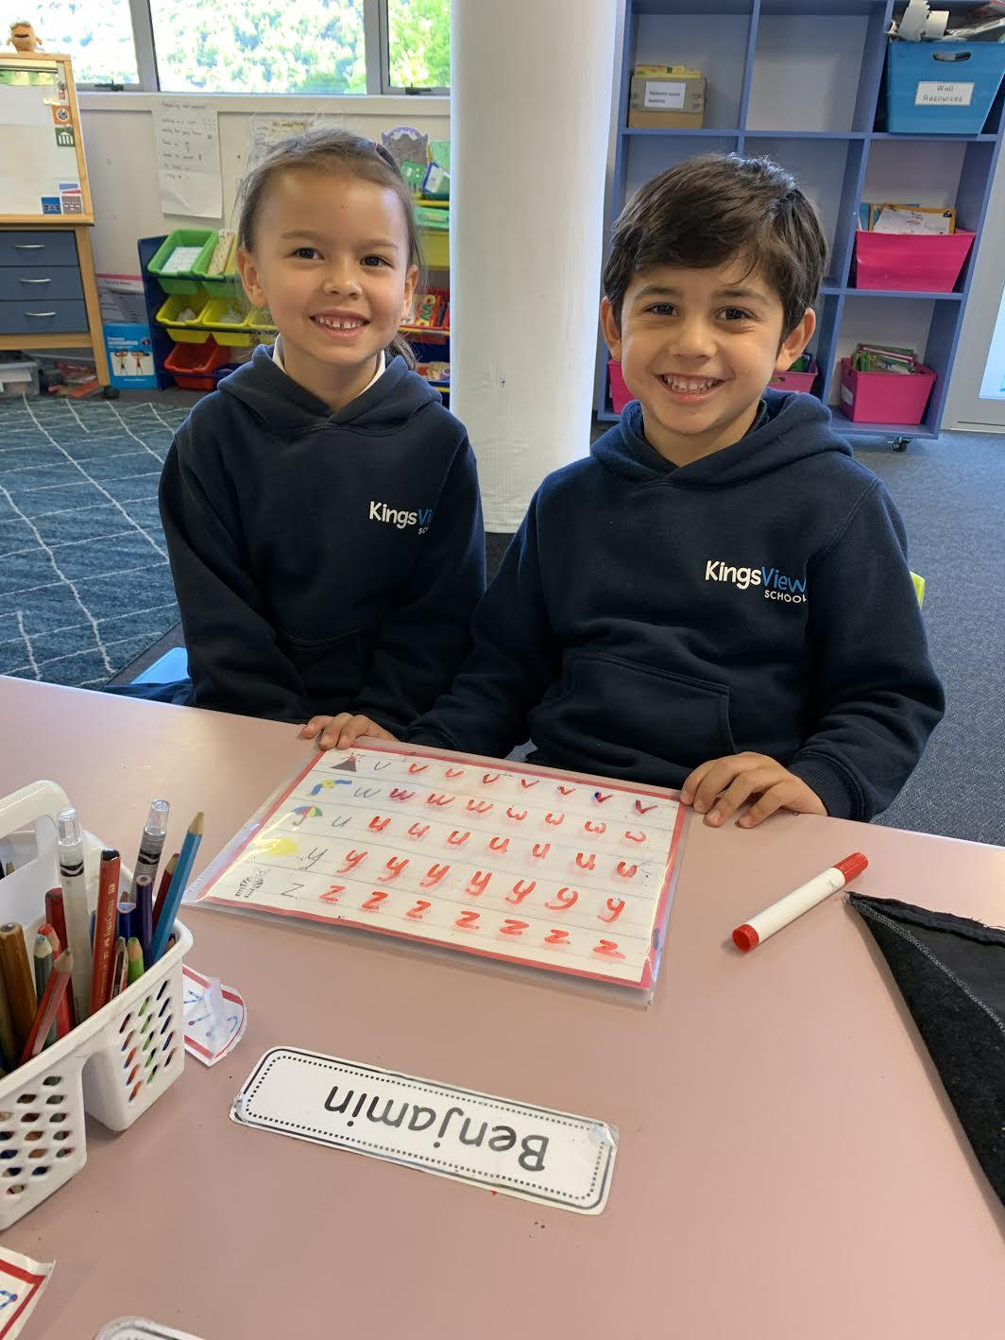 Room 1 | 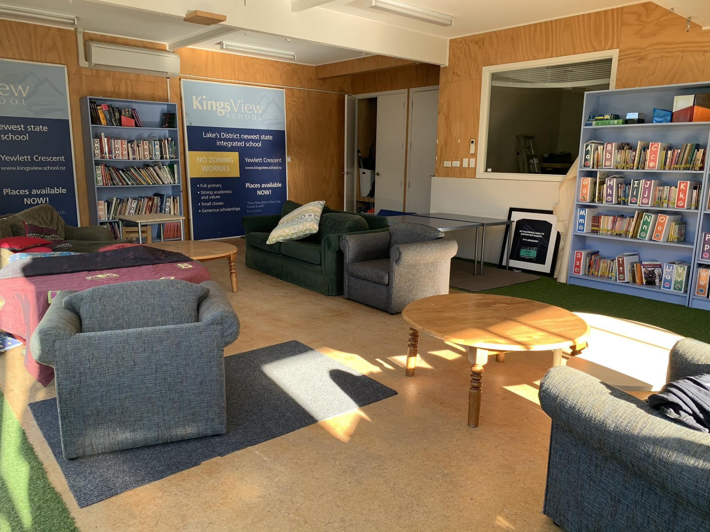  Our new look library….

COMMUNITY NOTICES:

“Join Kirsty for iNSPiRE April holiday programmes; nourishing, learning and growing - working on developing our personal skills and (toolkit of) positive well-being habits and affirming what it is to be a kind human! These holidays we are focusing on courage and self awareness.” See flyer below:

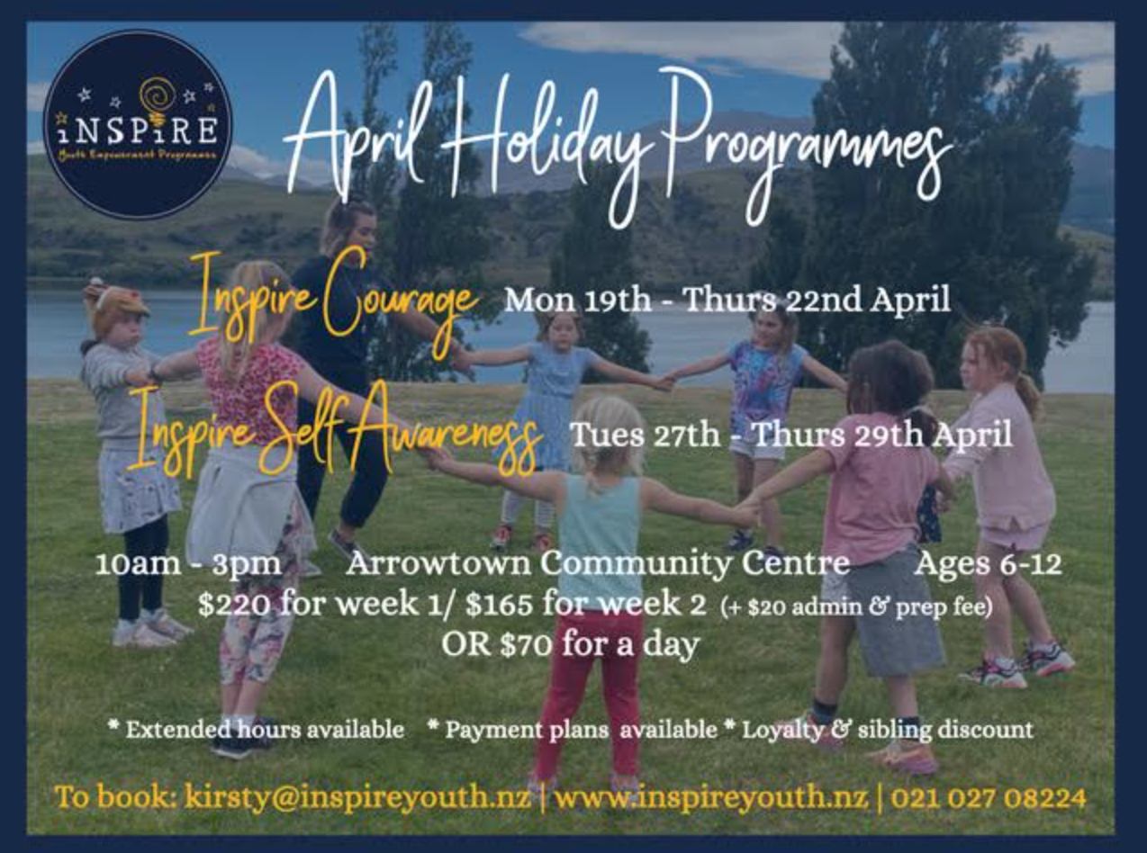

Attention students of Chinese descent:
I'm Sherry Zhang, the producer of OTHER [chinese], an award-winning documentary theatre show coming to the Dunedin Arts Festival and Festival of Colour. We are looking for people of chinese descent to participate in our project: exploring what it means to be Chinese in Aotearoa.

Our Wanaka Show is on the 13th of April, (15+16th in Dunedin) and participants don't need to prepare anything! Just bring themselves, and we will facilitate the storytelling experience.

Would you be able to point me in the right direction? I'd love to touch base with any of the chinese students + families in the Queenstown Area!

Here's a link to the show on festival pages! DAF + Festival of colour And those interested can sign up here.

And more about our team: White_mess

